Test Case1:

- Create a new strategy product.
- The strategy product state will be “ON-HOLD”
- Put in quotes for the legs
- Rest a strategy order in the spread book.
- The product state should open.

Test Case 2: (continuation from Testcase1)
- Now cancel all the quotes by clicking the OUT button on the bottom right hand corner of the trader gui.
- Cancel the strategy order.
- Put in a new order for the strategy product. See the product state go back to on-hold

Test Case 3:
- Create a new strategy product.
- The strategy product state will be “ON-HOLD”
- Put in wide quotes for the legs (1X100 – 7X100 depending on the EPW that is set)
The products will not open
- Rest a strategy order in the spread book. The product state should switch to opening rotation.

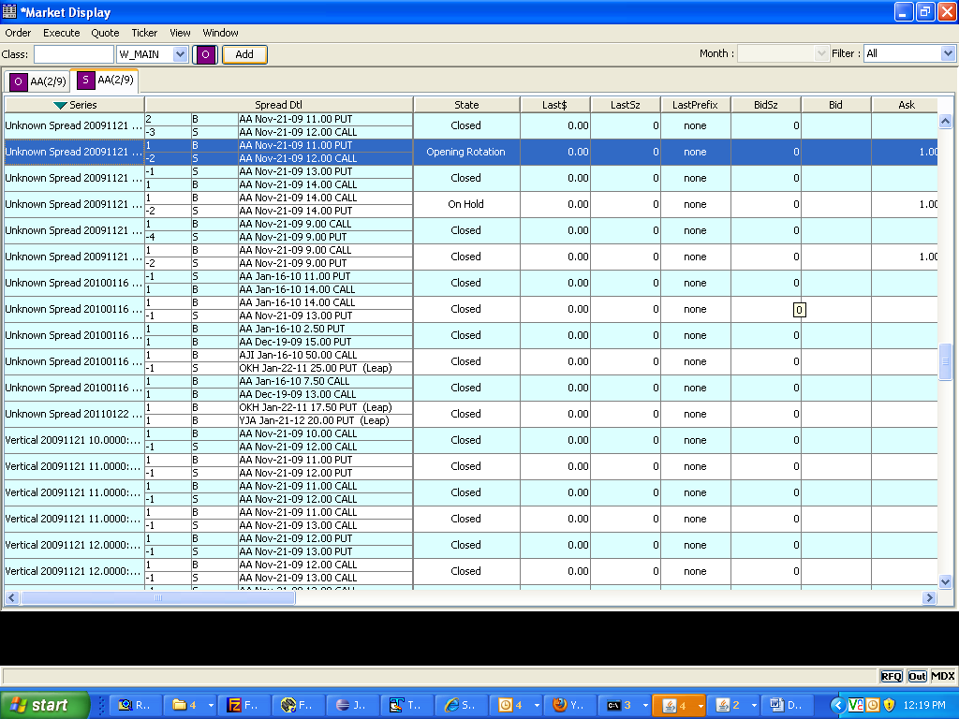
- Now change the quotes to 1 – 1.2 X100
- The product states for both the legs and the strategy product should open.
